MAINCRAFTS TECHNOLOGY

INTERNSHIP TASK 1

Student Management Database Using SQL

Internship Task: Task 1 — Student Management Database
Submitted by: Pavitra Juttanavar
Tool Used: MySQL Workbench
Database Name: StudentManagement
Table Name: Students

1. Objective

The objective of this task is to create a student management database and analyse students' academic performance using SQL queries.

2. Database Creation

Created a database named "StudentManagement" and a table named "Students" containing student IDs, names, gender, age, grades, and marks in Maths, Science, and English.

3. Data Insertion

Inserted 10 sample student records into the Students table using the SQL "INSERT INTO" statement.

4. SQL Queries Performed

1. Displayed all student records using "SELECT".
2. Calculated average marks in Maths, Science, and English using "AVG()".
3. Identified the top performer using "ORDER BY" and "LIMIT".
4. Counted students in each grade using "COUNT()" and "GROUP BY".
5. Calculated average subject marks by gender.
6. Retrieved students scoring above 80 in Maths using "WHERE".
7. Updated a student's grade using "UPDATE" and verified the result.

5. Results and Findings

- Average Maths score: 82.8
- Average Science score: 83.6
- Average English score: 82.8
- Top performer: Sneha
- Highest total score: 286 out of 300
- Grade distribution: A — 5 students, B — 3 students, C — 2 students.

6. Conclusion

This task provided practical experience in SQL database creation, inserting records, retrieving data, filtering, sorting, grouping, calculating averages, and updating records. These SQL operations are useful for analysing data and supporting data-driven decisions.

Note: The results are based on the sample dataset used for this assignment.

7.Screenshots of SQL Execution

Figure 1:Student records displayed using SELECT query.

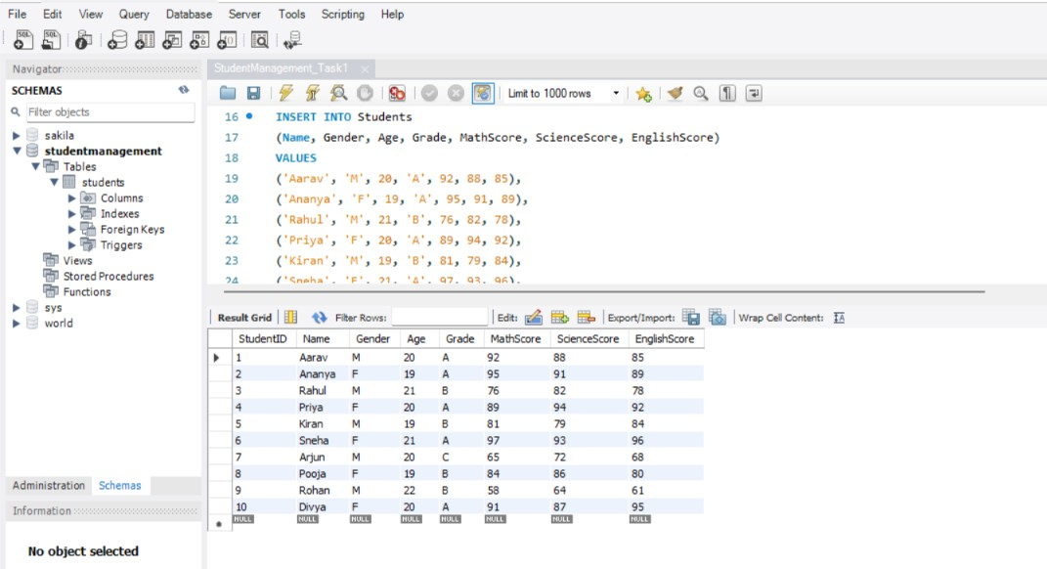

Figure 2: Analysis of student performance, including average subject scores and identification of the top-performing student.

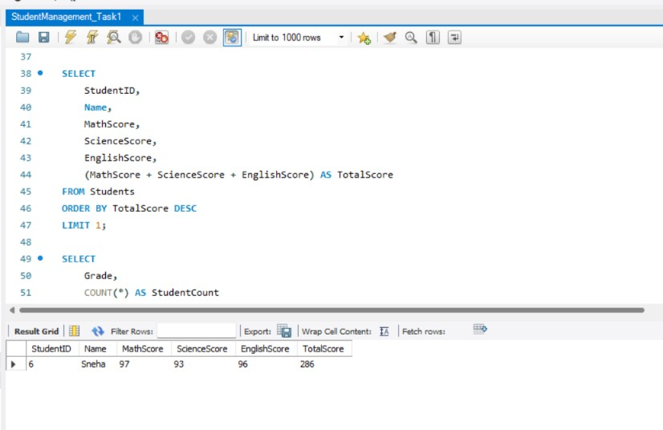

Figure 3: Verification of the grade update for student Rohan using an SQL SELECT query.

